Credit Analyst Interview Questions: 20 to Prepare For
Meta description: Credit analyst interview questions for bank, rating agency, leveraged finance and private credit seats: 20 questions with worked answers and the arithmetic.

Credit analyst interview questions test one thing: whether you can tell if a borrower will pay the money back, and what the lender gets if it doesn't. US leveraged loans outstanding hit a record $1.55 trillion at the end of 2025, and the banks, rating agencies and private credit funds that hold them all hire credit analysts. The questions shift by seat. A bank asks about coverage ratios and collateral, a rating agency about its scale and what moves a rating, a leveraged finance group about pricing and structure, and a private credit fund hands you a case.

Here are the 20 questions that come up across all four seats, with the answer the interviewer wants.

What does a credit analyst actually do?
A credit analyst decides whether a company can repay a loan, helps set the terms, and watches the borrower until the money comes back. At a bank that means the credit memo and the risk rating; at a rating agency it means "in-depth analysis of a select credit ratings portfolio," in Moody's words, plus a seat in the committee that sets the grade. In leveraged finance the analyst structures and sells the loans that fund buyouts, and in private credit the fund is the lender, so the analyst underwrites the loan it will hold to maturity. Every seat asks the same two things: will this borrower pay, and what does the lender get if it doesn't.

How technical is a credit analyst interview?
It depends on the seat. Commercial bank credit interviews "are rarely technical," per Mergers & Inquisitions: fit questions plus basic accounting and the ratios in questions 2 and 8. Rating agencies ask you to walk the scale and explain what moves a rating. Leveraged finance recruiting mirrors other investment banking groups with more technical questions, and private credit funds add a case: a quick read of an information memo with a lend or pass decision, or a 90-minute to three or four hour model with a downside case. "Most private credit case studies are like 3-statement models or LBO models, but with simpler mechanics," per M&I.

Questions every credit seat asks
1. How would you decide whether to lend $10 million to a company?

The interviewer wants a fixed order of questions, and the five Cs of credit (character, capacity, capital, collateral, conditions) are that order.

The Secured Finance Network calls the five Cs "the important general characteristics that lenders should consider and evaluate."

Character is whether the people running the company pay their bills: payment history, lawsuits, how they treated lenders the last time business slowed. Capacity is whether the cash flow covers the loan, and it's where the numbers live. Say the company earns $4 million of EBITDA and the $10 million loan costs 8 percent with 10 percent of the principal due each year: $0.8 million of interest plus $1 million of principal, $1.8 million a year against $4 million of earnings before capex and taxes. Capital is how much of the owners' own money sits under the loan: $10 million of debt on $15 million of equity is a different loan from $10 million on $2 million, because the equity absorbs the first losses. Collateral is what you take if the cash flow fails, valued at what it would sell for in a hurry. Conditions are the loan's purpose, the industry, and where rates are.

Give the five Cs in order, put a number under capacity, and end with a yes or no plus the covenant you'd want.

2. Which metrics tell you a company can carry its debt?

Lenders lean on four ratios, and each one answers a different question about the same borrower.

Leverage is total debt divided by EBITDA, and it says how many years of earnings the debt represents; at 5.5x, the large-cap buyout average in question 17, that's five and a half years.

Interest coverage is EBITDA divided by interest expense. At 2.0x the company earns twice its interest bill before capex and taxes.

DSCR, the debt service coverage ratio, divides the cash available for debt payments by interest plus scheduled principal. Banks want 1.25x at minimum.

FCCR, the fixed charge coverage ratio, widens the denominator to every fixed charge, including rent and leases. Definitions vary by credit agreement. M&I's direct lending guide writes it as EBIT plus the non-interest fixed charges, over those fixed charges plus interest plus mandatory principal. Say which definition you're using, because the one in the loan agreement is the one that gets tested.

Liquidity sits alongside the four: cash plus the undrawn revolver (the credit line a company can draw and repay as it needs), against the next 12 months of payments.

Give all four ratios with the question each one answers, then say which one the lender's covenant would test.

3. How do you get from EBITDA to the cash that actually pays the loan?

EBITDA comes before the four things a lender cares about most, so the bridge subtracts them one at a time: cash interest, cash taxes, capital spending and the cash tied up in working capital.

Start with EBITDA. Subtract cash interest, because the lender's coupon is paid before anything reaches principal. Subtract cash taxes, the amount actually paid. Subtract capex, because a company that stops replacing its trucks stops earning. Subtract the increase in net working capital: if receivables and inventory grew faster than payables, cash went into the business and isn't available for the loan.

Line | $ millions
EBITDA | 100
Less: cash interest | (30)
Less: cash taxes | (12)
Less: capital expenditures | (20)
Less: increase in net working capital | (8)
Free cash flow for debt repayment | 30

Then compare the result with the debt: against $500 million of loans, $30 million a year repays 6 percent of the balance, or 30 percent in five years.

Walk the five lines, then compare the result with the principal, because that's the number that says whether the loan gets repaid.

4. What is EBITDA, and what's wrong with using it for debt capacity?

EBITDA is operating earnings with depreciation and amortization added back, and it overstates the cash a capex-heavy business can pay its lenders.

From net income, add back taxes, interest, depreciation and amortization. From operating income, add back depreciation and amortization only. Lenders quote leverage multiples on it because it strips out financing and tax choices. WSG's EBITDA post walks the calculation.

Two things go wrong when you size debt on it. First, depreciation is a real cost over time for a trucking company or a steel mill. Take two companies with $100 million of EBITDA. A software company spends $5 million a year on capex and a trucking company spends $40 million. After $30 million of interest and $12 million of cash taxes, the software company has $53 million left for principal and the trucking company has $18 million. Same EBITDA, nearly three times the cash. Second, "adjusted EBITDA" in a buyout marketing deck adds back restructuring costs, projected synergies and one-time items, and the covenant definition in the loan agreement decides which of those count.

Define it in one line, then name the two failures, capex and add-backs, and say which cash number you'd use instead.

5. What's the difference between a maintenance covenant and an incurrence covenant?

A maintenance covenant is tested every quarter whether or not the borrower does anything, and an incurrence covenant is tested only when the borrower acts.

PitchBook LCD's leveraged loan primer: maintenance covenants "require an issuer to meet certain financial tests every quarter, whether or not it takes an action," while an incurrence covenant "is tested only if an issuer takes an action, such as issuing debt or making an acquisition." With a 6.0x maximum leverage maintenance covenant, a borrower at 6.1x in any quarter is in default, and the lenders can charge a fee, reprice the loan or call it. With a 6.0x incurrence test, the same borrower at 6.5x is not in default. It just can't borrow more or pay a dividend until it's back under the line.

Cov-lite loans, in LCD's words, are "loans that have bond-like financial incurrence covenants, rather than traditional maintenance covenants." Cov-lite deals passed 90 percent of US leveraged loan issuance in 2021, a new high at the time, per S&P Global Market Intelligence. A term loan B today has no maintenance covenants other than a springing test for the revolver lenders, per Ashurst's loan and bond comparison; springing means the test switches on only when the revolver is drawn past a set amount. Private credit kept more of the old protection: 77 percent of core middle market loans originated in 2024 had a maintenance covenant, per KBRA DLD, against 38 percent of large private loans.

Say when each one is tested, then add that syndicated term loans are almost all incurrence-only while most core middle market private loans still keep a quarterly test.

6. A borrower has $100 of EBITDA and $500 of debt at 6 percent, with a 6.0x maximum leverage covenant and a 2.0x minimum interest coverage covenant. How much cushion is there?

The cushion is how far EBITDA can fall before a covenant breaks, and here the leverage test breaks first, after a 16.7 percent drop.

Leverage today is $500 divided by $100, or 5.0x. The covenant allows 6.0x, so the lowest EBITDA that still passes is $500 divided by 6.0, which is $83.3. EBITDA can fall by $16.7 before the test breaks, and $16.7 is 16.7 percent of $100.

Now the coverage test. Interest is 6 percent of $500, or $30. Coverage today is $100 divided by $30, or 3.3x. The lowest EBITDA that still passes 2.0x is 2.0 times $30, which is $60. EBITDA can fall by $40 before that test breaks, a 40 percent cushion.

Test | Covenant | Today | EBITDA at the limit | Cushion
Leverage (debt / EBITDA) | 6.0x maximum | 5.0x | $83.3 | $16.7, or 16.7 percent
Interest coverage (EBITDA / interest) | 2.0x minimum | 3.3x | $60.0 | $40.0, or 40 percent

The leverage covenant binds first. If EBITDA falls 17 percent, the borrower trips the leverage test while still covering its interest about 2.8 times. Proskauer wrote in 2023 that cushions historically sat around 25 percent of EBITDA and that almost all recent private credit deals set 30 percent or more, so 16.7 percent is tight.

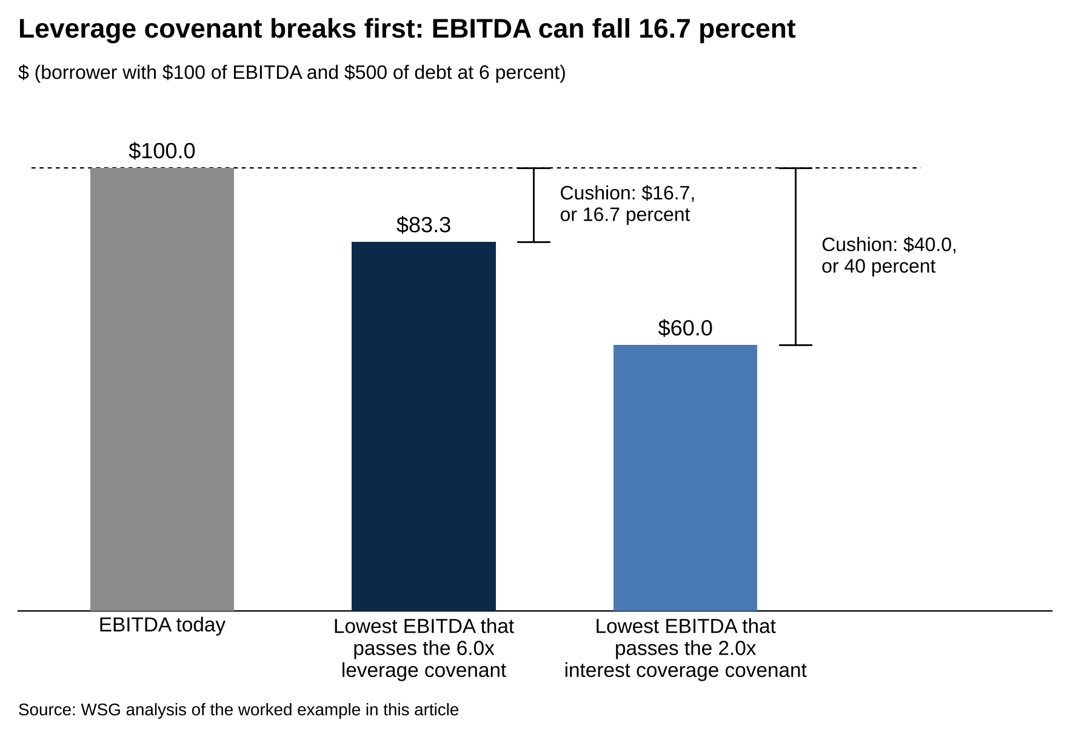
EBITDA can fall $16.7 before the 6.0x leverage test breaks and $40.0 before the 2.0x coverage test breaks.
Source: WSG analysis of the worked example in this article.

Compute both cushions in dollars and in percent, name the one that binds, and say whether it's tight against the 30 percent that recent deals carry.

7. Who gets paid first if the company goes bankrupt?

Secured lenders at the top of the capital structure get paid first, and Moody's long-run data shows first-lien loans recovering about 65 cents on the dollar against 38 cents for senior unsecured bonds.

The revolver and first-lien term loans have the first claim on the company's assets and are paid first. Second-lien loans share the same collateral with a junior claim. Senior unsecured bonds come next, then subordinated debt (mezzanine, PIK notes, vendor notes), then preferred stock. Common equity gets what's left "after all creditors are paid," as Corporate Finance Institute puts it.

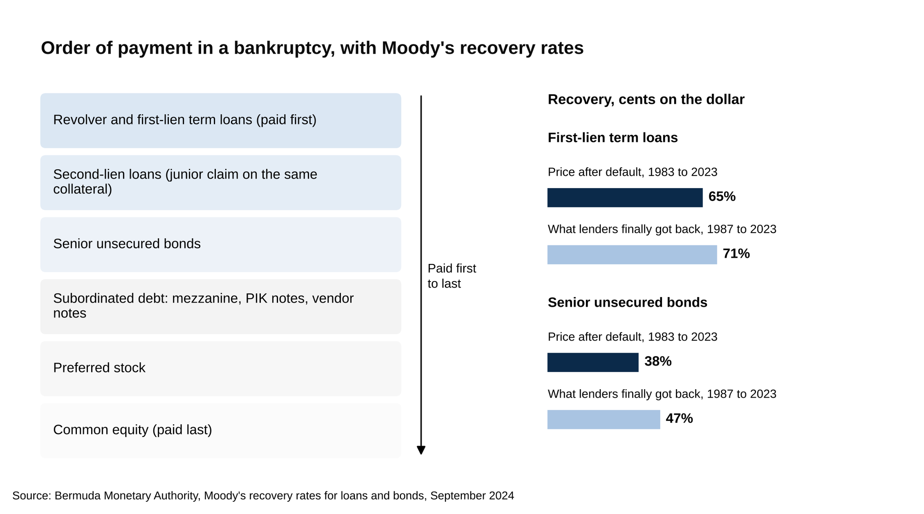
First-lien loans recovered 65 cents on the dollar against 38 for senior unsecured bonds, on Moody's trading prices.
Source: Bermuda Monetary Authority, Moody's recovery rates for loans and bonds, September 2024.

The 65 and 38 percent figures are Moody's trading-price recoveries from 1983 to 2023, cited in a Bermuda Monetary Authority paper. Measured on what lenders finally got back, 1987 to 2023, term loans recovered 71 percent and senior unsecured bonds 47 percent.

Name the stack from the revolver down to common stock, then give the recovery numbers, because a first-lien loan and an unsecured bond lose very different amounts in the same default.

Bank credit analyst questions
8. What is DSCR, and what minimum do banks want?

DSCR divides the cash a borrower has for debt payments by the interest and principal due, and most commercial banks want at least 1.25x.

Corporate Finance Institute's DSCR page says "most commercial banks and equipment finance firms want to see a minimum of 1.25x." At exactly 1.25x, debt payments take 80 percent of the available cash, which leaves 20 percent for a bad quarter.

A company has $2.5 million of cash available for debt service, and its loan costs $1.6 million of interest plus $0.4 million of principal a year, $2.0 million in total. DSCR is $2.5 million divided by $2.0 million, or 1.25x, exactly at the floor. If cash falls 10 percent to $2.25 million, DSCR drops to 1.13x and the covenant is broken.

Then say what goes in the numerator. M&I's direct lending guide uses free cash flow plus interest expense over interest plus mandatory principal.

Give the formula, the 1.25x floor, and one sentence on what's in the numerator, because that definition is where bank credit interviews go next.

9. What's a borrowing base, and how do advance rates work?

A borrowing base caps a revolver at a percentage of the collateral that's actually good, and the OCC's handbook puts the usual advance rate at 70 to 85 percent of eligible receivables and up to 65 percent of inventory.

An asset-based loan lends against receivables and inventory instead of cash flow. The bank first removes the receivables it won't count, such as invoices long past due, then applies an advance rate to the rest. The OCC's 2014 asset-based lending handbook describes receivable advance rates of 70 to 85 percent before dilution and reserves, and inventory advance rates of up to 65 percent of liquidation value, what it would fetch in a quick sale.

Borrowing base | $ millions
Eligible receivables | 10.0
At an 80 percent advance rate | 8.0
Inventory at liquidation value | 6.0
At a 50 percent advance rate | 3.0
Borrowing base | 11.0
Revolver commitment | 15.0
Amount drawn | 7.0
Availability (lesser of base and commitment, less drawn) | 4.0

The base moves with the collateral. If receivables fall to $7 million in a slow quarter, the receivables piece drops to $5.6 million, the base to $8.6 million, and availability to $1.6 million. If the base falls below the amount drawn, the borrower is in an overadvance and has to repay the difference.

Walk the two advance rates, add them into the base, subtract what's drawn, and say what happens when the base drops below the draw.

10. What's in a credit memo, and what do the risk ratings mean?

A credit memo answers the five Cs with numbers and ends in a risk rating, and regulators require four criticized grades below pass: special mention, substandard, doubtful and loss.

The memo covers the loan's purpose and structure, the company and industry, three years of the question 2 ratios, projections with a downside case, collateral at liquidation value, covenants, and a recommendation with a risk rating.

The OCC's "Rating Credit Risk" booklet governs how banks grade loans. Loans in good standing are pass credits; the FDIC's examination manual defines the four criticized grades below them. "A Special Mention asset has potential weaknesses that deserve management's close attention." "Substandard loans are inadequately protected by the current sound worth and paying capacity of the obligor." Doubtful loans "have all the weaknesses inherent in those classified Substandard," with full collection "highly questionable and improbable." Loans classified loss "are considered uncollectible and of such little value" that keeping them on the books isn't warranted.

Expected loss equals PD times LGD times EAD: the probability of default, the share of the exposure lost if default happens, and the exposure at default. A $10 million loan with a 2 percent probability of default and a 40 percent loss given default carries an expected loss of $80,000. Move it to substandard with a 10 percent probability of default and the expected loss becomes $400,000.

Name the sections, then the five grades in order with one line on what moves a loan from pass to special mention, because that line is the bank's early warning.

11. Why commercial banking rather than investment banking?

The answer that works is about the work itself: a commercial bank credit analyst owns a lending decision and a client relationship for years, while an investment banking analyst works a transaction until it closes.

JPMorgan's Middle Market Banking and Specialized Industries summer program, for example, ran nine weeks, introduced interns to client management, credit structuring and cash management, had them work on financial models for financing deals with bankers and credit officers, and could end in an offer to the 2.5-year MMBSI Analyst Program, per its posting for the 2026 summer [VERIFY: program length and structure on JPMorgan's current page].

Don't say: "The hours are better and I want a balanced life."

Say: "I want to be the person who decides whether the bank lends and then sees the loan through a downturn. Last month I read the loan footnotes in two bank 10-Ks to see how criticized loans moved; that's the work I want."

Say what the credit seat lets you own, name one thing you've already done that looks like it, and leave hours and pay out of the answer.

Rating agency questions
12. Can you walk me through the rating scale and where investment grade ends?

Investment grade ends at Baa3 on Moody's scale and BBB- on S&P's, and everything below that line is speculative grade.

S&P puts it directly: "Investment grade ratings from S&P Global Ratings include those rated BBB- or higher."

Moody's | S&P | Grade
Aaa | AAA | Investment grade
Aa1, Aa2, Aa3 | AA+, AA, AA- | Investment grade
A1, A2, A3 | A+, A, A- | Investment grade
Baa1, Baa2, Baa3 | BBB+, BBB, BBB- | Investment grade (lowest)
Ba1, Ba2, Ba3 | BB+, BB, BB- | Speculative grade
B1, B2, B3 | B+, B, B- | Speculative grade
Caa, Ca, C | CCC, CC, C, D | Speculative grade (near or in default)

Moody's rating symbols document says Baa obligations are "subject to moderate credit risk" and "may possess certain speculative characteristics," and Ba obligations "have speculative elements and are subject to substantial credit risk." S&P says a BBB obligation "exhibits adequate protection parameters" and a BB obligation "is less vulnerable to nonpayment than other speculative issues."

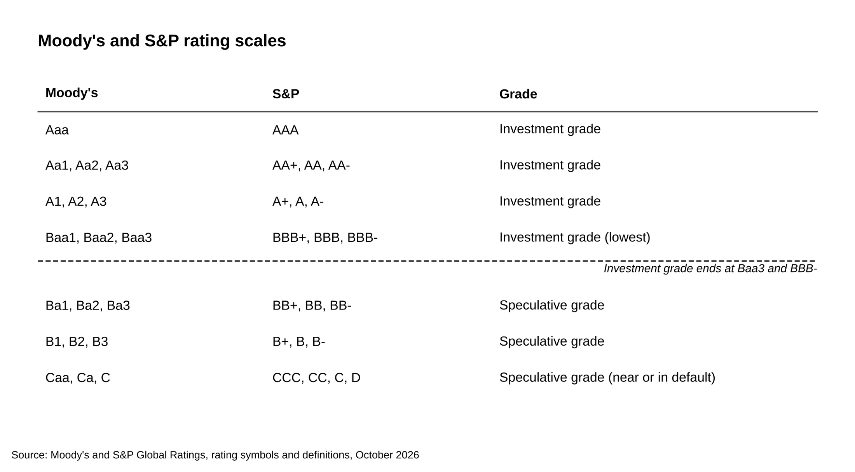
Investment grade ends at Baa3 on Moody's scale and BBB- on S&P's.
Source: Moody's and S&P Global Ratings, rating symbols and definitions, October 2026.

Give the two scales side by side, point to Baa3 and BBB- as the last investment grade notches, and quote one definition from each side of the line.

13. What's the difference between an outlook and a watch?

An outlook says where a rating is likely to go over six months to two years, and a watch says there's at least a one-in-two chance it changes within 90 days.

S&P's criteria say an outlook covers "the intermediate term (typically six months to two years)," and that CreditWatch applies when "there is at least a one-in-two likelihood of a rating change within 90 days." Moody's uses the same split: an outlook is "an opinion regarding the likely direction of an issuer's rating over the medium term," with positive, negative, stable and developing as the four labels, and "Moody's uses the Watchlist to indicate that a rating is under review for possible change in the short-term."

One outlook in use: S&P cut Adecco from BBB+ to BBB on November 17, 2025 with a stable outlook, meaning it expected the new rating to hold. Question 14 shows a watch.

Say outlook equals direction over the medium term and watch equals a likely move within about 90 days, then give the four outlook labels.

14. Why would an agency downgrade a company that still makes money?

A rating measures the chance a lender gets paid in full, so an agency downgrades when debt grows faster than earnings, when the business shrinks, or when management puts new lenders ahead of old ones.

Warner Bros. Discovery in 2025 hit all three within a month. S&P cut it to junk on May 20, 2025. On June 11, Fitch cut its issuer default rating from BBB- to BB+ and put it on negative watch, saying the company after its planned split would be "smaller and less diversified in a secularly declining industry." Moody's cut the senior unsecured notes from Baa3 to Ba1, on review for downgrade, citing "WBD's persistent operating challenges and a change in its financial policies" and "the declining linear television business," as TheWrap reported. That's all three triggers: falling cable earnings, a split that left the rated debt with a smaller company, and secured debt added ahead of the old unsecured notes.

The same action shows notching. Fitch rated the WarnerMedia Holdings notes BB+ with an RR4 recovery rating, Fitch's 31 to 50 percent expected recovery band, so those notes sit level with the company. It rated the older WarnerMedia notes BB with an RR5, the 11 to 30 percent band, one notch lower.

A shorter example: S&P cut Adecco in November 2025 for "persistently high leverage," expected at about 2.0x instead of 1.6x, though the company was still profitable.

Answer with the three triggers, then give Warner Bros. Discovery as the example, because it hit all three within a month.

Leveraged finance questions
15. What's the difference between a leveraged loan and a high-yield bond?

A leveraged loan floats, is secured, amortizes and can be repaid at any time, at a small premium during a six-month to one-year soft call, while a high-yield bond is fixed-rate, usually unsecured, repaid at maturity and locked against early repayment for two to five years.

Feature | Leveraged loan (term loan B) | High-yield bond
Interest | Floating: SOFR plus a spread | Fixed coupon
Security | Usually secured, first lien | Usually unsecured
Repayment | Amortizes, plus mandatory prepayments | Bullet at maturity
Call protection | Callable any time; at best a 101 soft call for six months or a year | Non-call for 2 to 5 years, then declining premiums
Covenants | Springing maintenance test on the revolver, otherwise incurrence | Incurrence only
Buyers | Institutional loan accounts | Bond investors

A floating rate means the lender earns more when SOFR rises, and the borrower's coverage falls at the same time. Amortization means the loan balance shrinks on a schedule every year, while a bond sits at par until maturity. A soft call means the borrower pays 101 to repay in the first six months or year and par after that, so a loan borrower can reprice soon after the market tightens, while a bond's non-call period protects the investor's coupon for years. Fitch's trailing 12-month figures for July 2026 put leveraged loan defaults at about 3.8 percent and high-yield bond defaults at 2.7 percent [VERIFY: Fitch's latest monthly default figures; the July numbers come from a secondary summary].

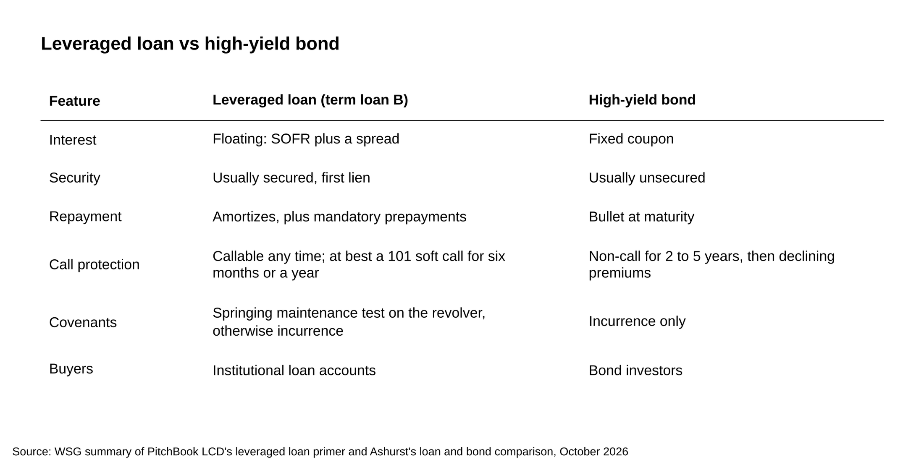
A leveraged loan floats, is secured and amortizes; a high-yield bond is fixed-rate, usually unsecured and repaid at maturity.
Source: WSG summary of PitchBook LCD's leveraged loan primer and Ashurst's loan and bond comparison, October 2026.

Run the six rows in order and say what each one does to the lender's risk, with the 65 versus 38 percent recovery as the reason security matters.

16. How is a term loan B priced, and what do a floor and an OID do to the yield?

A term loan B pays a spread over SOFR, a floor sets the lowest base rate the lender will accept, and an OID is a discount at issue that adds to the yield over the life of the loan.

A loan priced at SOFR plus 250 pays the base rate plus 2.50 percent. The floor protects the lender when rates fall: in LCD's words, "if a loan has a 3% Sofr floor and Sofr falls below this level, the base rate for any resets defaults to 3%." The OID pays the lender up front. LCD again: "If a loan is issued at 99 cents on the dollar to pay par, the OID is said to be 100 bps, or 1 point."

Layer | Example | Effect on the yield
Spread | SOFR + 250 | Coupon is the base rate plus 2.50 percent
Base rate | SOFR at 3.87 percent on October 8, 2026, per the New York Fed [VERIFY: SOFR level at publish] | Coupon of 6.37 percent
Floor | 3.00 percent | If SOFR fell to 2 percent, the coupon would be 5.50 percent, not 4.50
OID | 99, or 1 point | About 25 bps a year over a four-year life
All-in yield |  | About 6.6 percent

Two follow-ups: a term loan A amortizes over six years or less and goes to banks, while a term loan B is "carved out for nonbank, institutional accounts" and traditionally repays in a bullet, per LCD. A second-lien loan prices at a premium to first lien that "typically starts at 200 bps."

Build the yield in layers, base rate, spread, floor and OID, then say the floor protects the lender when rates fall and the OID pays the lender up front.

17. A sponsor wants 7x debt to EBITDA instead of 5x. How do you evaluate it?

At 7x the interest bill takes most of the earnings, so the evaluation is the same three numbers at both leverage levels: interest coverage, free cash flow after interest, and the years it takes to repay half the debt.

The sponsor is the private equity firm buying the company. KBRA DLD's December 2025 data put large-cap buyouts at 5.5x total debt to EBITDA, the core middle market at 4.75x and the lower middle market at 4.1x. Bank regulators' 2013 leveraged lending guidance was read as treating total debt above 6.0x EBITDA as a concern and expected borrowers to repay about half their debt in five to seven years; the OCC and FDIC rescinded it on December 5, 2025 [VERIFY: whether the Federal Reserve has since rescinded or kept the guidance].

Run it on $100 million of EBITDA, with an 8 percent rate, $10 million of capex and $10 million of cash taxes assumed at both levels.

$ millions | 5.0x | 7.0x
Debt | 500 | 700
Interest at 8 percent | 40 | 56
Interest coverage (EBITDA / interest) | 2.5x | 1.8x
Free cash flow (EBITDA less interest, capex, cash taxes) | 40 | 24
Years to repay half the debt from free cash flow | 6.3 | 14.6
Interest coverage if EBITDA falls 30 percent to $70 million | 1.75x | 1.25x
Free cash flow if EBITDA falls 30 percent (cash taxes drop to $5 million) | 15 | (1)

At 7x the payback stretches to nearly 15 years and the downside case leaves nothing for principal. You can still say yes, with more equity under the loan, faster amortization or a tighter covenant, and the answer is to say which.

Run coverage, free cash flow and the payback at both levels, then show the 30 percent downside, because at 7x that case has no cash left for principal.

Private credit questions
18. What's the difference between private credit and broadly syndicated loans, and why did it grow?

A private credit loan is made by one fund or a small club and held to maturity, a broadly syndicated loan is arranged by a bank and sold to many institutional accounts, and private credit financed 84 percent of US buyouts by count in 2025.

The lender: a private credit fund lends its investors' money and keeps the loan, while a syndicated loan is arranged by a bank and sold on. The price: price flex lets a syndicating bank move the spread until the deal closes, per LCD's primer, while a private lender signs a price up front; unitranche loans clustered at SOFR plus 450 to 500 bps in October 2025, per PitchBook's private credit monitor. The covenants: the 77 percent against 38 percent split from question 5. The size: Blue Owl led a $1.4 billion private loan for Hg's roughly $6.4 billion acquisition of OneStream in February 2026, per Bloomberg.

Private credit financed 214 US buyouts in 2025, 84 percent of the count, while the syndicated market financed 42 percent of the volume, per Kirkland's January 2026 review. Moody's expects private credit assets to pass $2 trillion in 2026 and approach $4 trillion by 2030. Sponsors pay the 450 to 500 bps for one lender and a price signed up front instead of a spread that can flex before closing. Lenders take that risk for the wider spread and, in the core middle market, a quarterly covenant test.

Give the four differences, lender, price, covenants and size, then the 84 percent by count and 42 percent by volume figures, because the interviewer wants the mechanism and the number together.

19. What's a unitranche, and how does PIK interest work?

A unitranche is one loan agreement with one blended rate that replaces separate senior and junior loans, and PIK interest is interest the borrower adds to the loan balance instead of paying in cash.

Wall Street Prep describes a unitranche as "structured as a single financing arrangement comprised of a roll-up of separate tranches." The borrower sees one loan. Behind it, an agreement among lenders splits them into a first-out piece, which gets paid first and earns a lower rate, and a last-out piece, which gets paid after and earns more; the blended rate sits at or above senior pricing and below second-lien pricing. A $300 million unitranche with a $150 million first-out piece at SOFR plus 350 and a $150 million last-out piece at SOFR plus 700 costs the borrower SOFR plus 525 on the whole loan, and the agreement among lenders decides who absorbs the first loss.

PIK stands for payment in kind. Instead of paying interest in cash, the borrower adds it to the principal, so the debt compounds.

$100 million loan at 10 percent PIK | Year 1 | Year 2 | Year 3
Opening balance | 100.0 | 110.0 | 121.0
PIK interest added | 10.0 | 11.0 | 12.1
Closing balance | 110.0 | 121.0 | 133.1
Cash interest paid | 0 | 0 | 0

No cash leaves the company, which is why a lender offers PIK to a borrower that's growing fast or short of cash today. The cost is that the claim grows 10 percent a year whether or not earnings do: on flat EBITDA of $25 million, leverage goes from 4.0x to 5.3x in three years.

Explain the first-out and last-out split for a unitranche, then show one year of PIK compounding and say what it does to leverage.

20. Build a downside case: if EBITDA falls 30 percent, does this loan still get repaid?

A downside case reruns the cash flow bridge and the ratios with lower earnings and the same debt, and the loan survives if free cash flow stays positive and the ratios stay inside the covenants.

State every assumption before you start.

- EBITDA: $50 million in the base case, $35 million after a 30 percent decline.
- Debt: 5.0x senior at $250 million, a unitranche priced at SOFR plus 500. SOFR was 3.87 percent on October 8, 2026 [VERIFY: SOFR level at publish], rounded to 4 percent, so the rate is 9 percent and cash interest is $22.5 million.
- Amortization: 1 percent a year, $2.5 million.
- Capex: $5 million in both cases.
- Cash taxes: $5 million in the base case, $2 million in the downside, because lower earnings mean a lower tax bill.
- Working capital: no change.
- FCCR for this case: EBITDA less capex less cash taxes, divided by cash interest plus scheduled principal.

$ millions | Base case | EBITDA down 30 percent
EBITDA | 50.0 | 35.0
Less: cash interest (9 percent on $250 million) | (22.5) | (22.5)
Less: capex | (5.0) | (5.0)
Less: cash taxes | (5.0) | (2.0)
Free cash flow before principal | 17.5 | 5.5
Less: amortization (1 percent) | (2.5) | (2.5)
Cash left after debt service | 15.0 | 3.0
FCCR | 1.60x | 1.12x
Leverage (debt / EBITDA) | 5.0x | 7.1x

In the base case the borrower covers its fixed charges 1.6 times and has $15 million a year to prepay the loan. In the downside, the cash still covers interest and the 1 percent amortization with $3 million to spare. But FCCR falls to 1.12x, under the 1.25x floor a bank would set, and leverage jumps from 5.0x to 7.1x, through a 6.0x maintenance covenant. So the answer has two parts. The cash covers the payments. The covenants break, which puts the lender at the table to reprice, take a fee or demand equity before the money is lost.

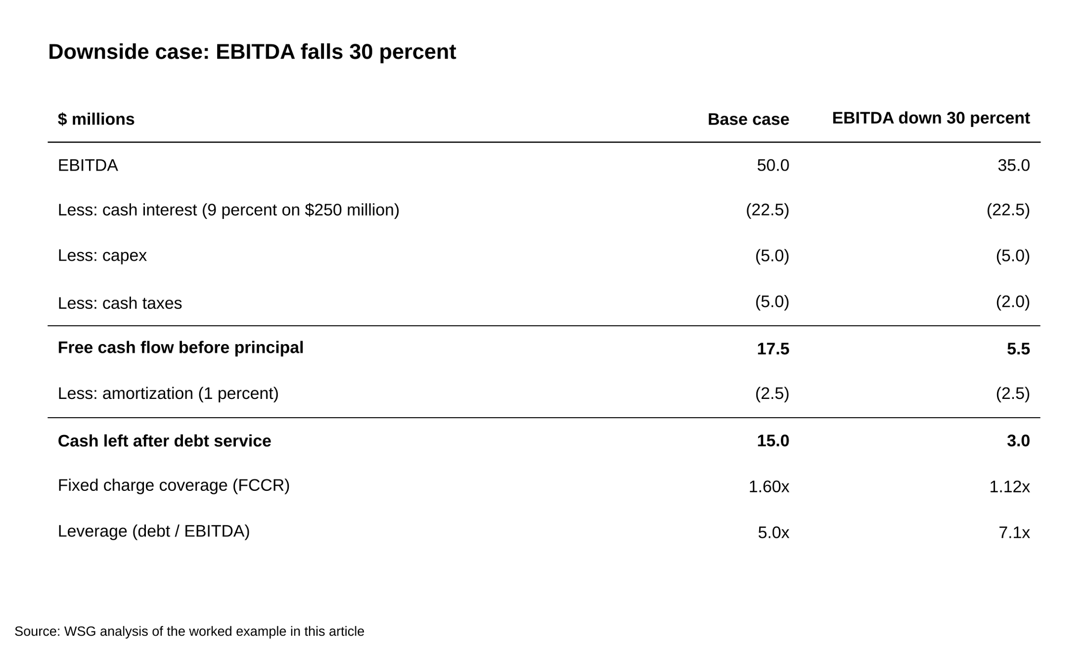
FCCR falls from 1.60x to 1.12x and leverage rises from 5.0x to 7.1x when EBITDA drops 30 percent.
Source: WSG analysis of the worked example in this article.

State every assumption, show both columns, and answer in two parts: the cash still covers the payments, and the covenants break, so the lender gets to renegotiate before the money is lost.

Questions not on this list
The current SOFR and Treasury levels are on Corporate Finance Institute's credit analyst question list; check the New York Fed's SOFR page and the Treasury yield curve the morning of the interview.

M&I lists yield to maturity, yield to call and yield to worst among its private credit questions. Yield to maturity is the return if the bond runs to its final date, yield to call is the return if the issuer redeems it at the first call date, and yield to worst is the lowest of the yields across every call date, which is the one a lender underwrites to.

Workout versus restructuring is about who's in the room. In a workout the lender and borrower renegotiate privately, through an amendment, a waiver or a maturity extension, before any court is involved; a restructuring is the formal version, in or outside Chapter 11, that rewrites the capital structure. WSG's restructuring interview questions post covers that side. "What do the rating agencies do?" gets one line: they publish an independent opinion of the chance a borrower pays in full. Every seat assumes the three statements and the accounting behind EBITDA; WSG's 50 accounting interview questions covers them.

Say this, don't say that
Why credit rather than private equity?

Don't say: "Private equity is too competitive, and credit has a better lifestyle."

Say: "I want to be the one deciding whether the money goes out and on what terms. In credit the downside case is the job, and I'd rather spend my time on what can go wrong."

Would you lend to this company?

Don't say: "Yes, the EBITDA margins look strong."

Say: "Yes at 4.5x senior with a 1.25x fixed charge covenant and a 30 percent cushion, because at 9 percent a 30 percent EBITDA decline still covers interest about 1.7 times. At 6x I'd pass."

What's the biggest risk in this loan?

Don't say: "The economy could slow down."

Say: "Customer concentration. The top customer is 35 percent of revenue, and losing it takes EBITDA down about a quarter, which breaks a 6.0x leverage covenant from 5.0x today."

Why our firm?

Don't say: "You're a leader in private credit."

Say: "You hold what you originate and keep maintenance covenants in the core middle market, and I want to learn underwriting where the lender still gets a quarterly test."

What's happening in the loan market right now?

Don't say: "Rates are high and defaults are rising."

Say: "SOFR is around 3.9 percent, Fitch's private credit default rate hit a new high of 6.3 percent through August, and leveraged loan defaults ran about 3.8 percent in July, so I'd underwrite to a wider downside than two years ago." [VERIFY: refresh the three figures at publish]

Where to start by seat
For a bank credit seat, learn the five Cs, DSCR and the borrowing base cold, then read the FDIC's five grades until you can recite them. Pull one public bank's 10-K and find the table of criticized loans.

For a rating agency, memorize both scales and the definitions quoted in question 12, then read the Fitch and Moody's releases on Warner Bros. Discovery.

For leveraged finance, read PitchBook LCD's leveraged loan primer end to end and rebuild the tables in questions 16 and 17 with your own numbers.

For private credit, build question 20 in Excel from a real 10-K, three statements down to a debt schedule, and practice the lend-or-pass read on a company you follow. WSG's 20 private credit interview questions, its 20 examples of private credit interview questions, the direct lending careers post and the guide to breaking into private credit as an undergrad cover the rest of that path.

Whichever seat it is, do question 6 and question 20 on paper this week, with your own numbers, until the arithmetic takes under five minutes. Those two are the ones interviewers use to see whether you can lend.

